Group 5 – Ian Murray, Ronan Monahan, Muireann Walsh, Paula Siuciu, Ger Hennessy, Fergal Byrne.

This is a brief, largely pictographic, representation of the functionality of our project. Beginning with login, and ending with logout, this is a logical path through the UI.

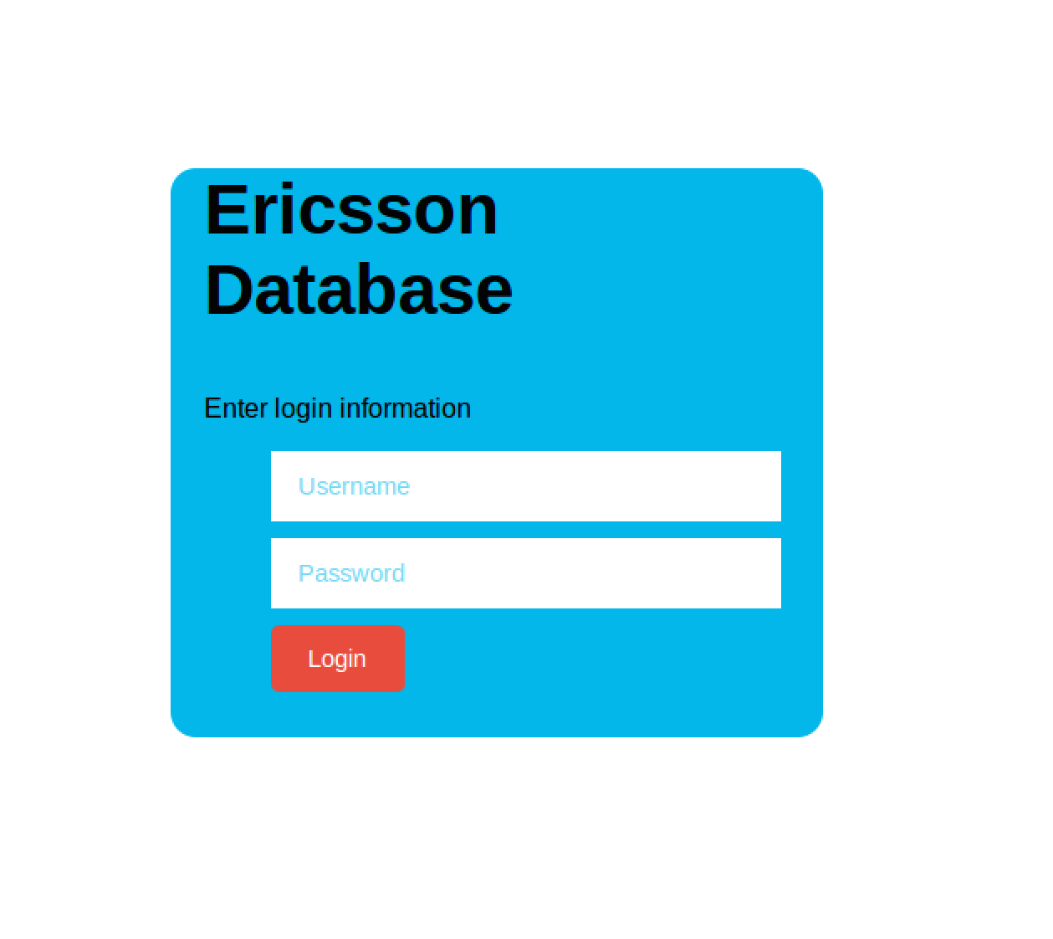

At the login page you will be prompted to enter a valid username and password. Failing to enter the correct information will result in the “Enter login information” text changing to “Incorrect username or password”. Successful login will redirect you to the main page, and the users level is put in local storage so that the users level of access can be checked on each page they access, ensuring no user with insufficient user level can access queries or pages beyond them.



This is the default main page. It provides a link to the Ericsson home page inside a frame, with full functionality.

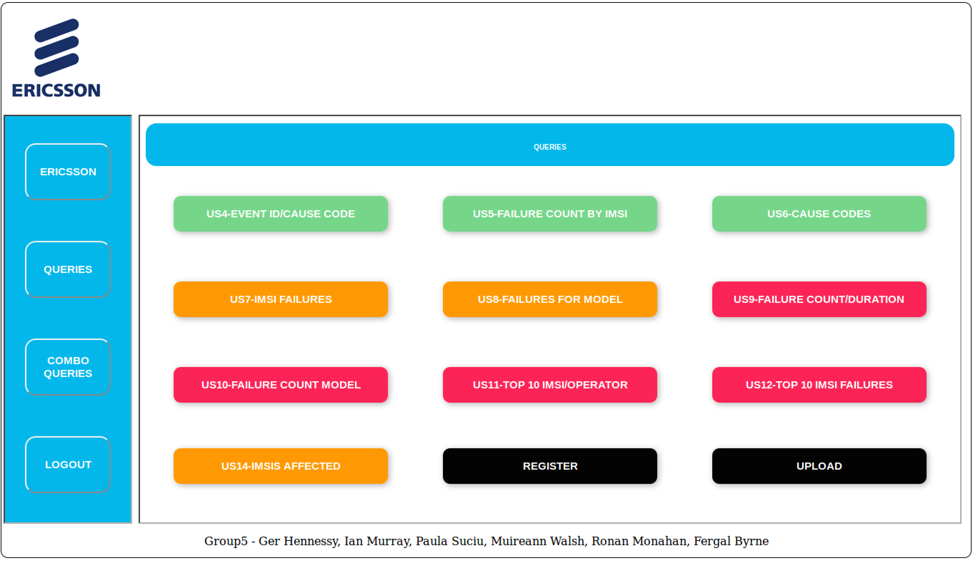

This is the main query page, with System Administrator level of access. Each button is a link to a query or function. They are colour coded according to user level, and hovering over them shows a brief description of each queries process.

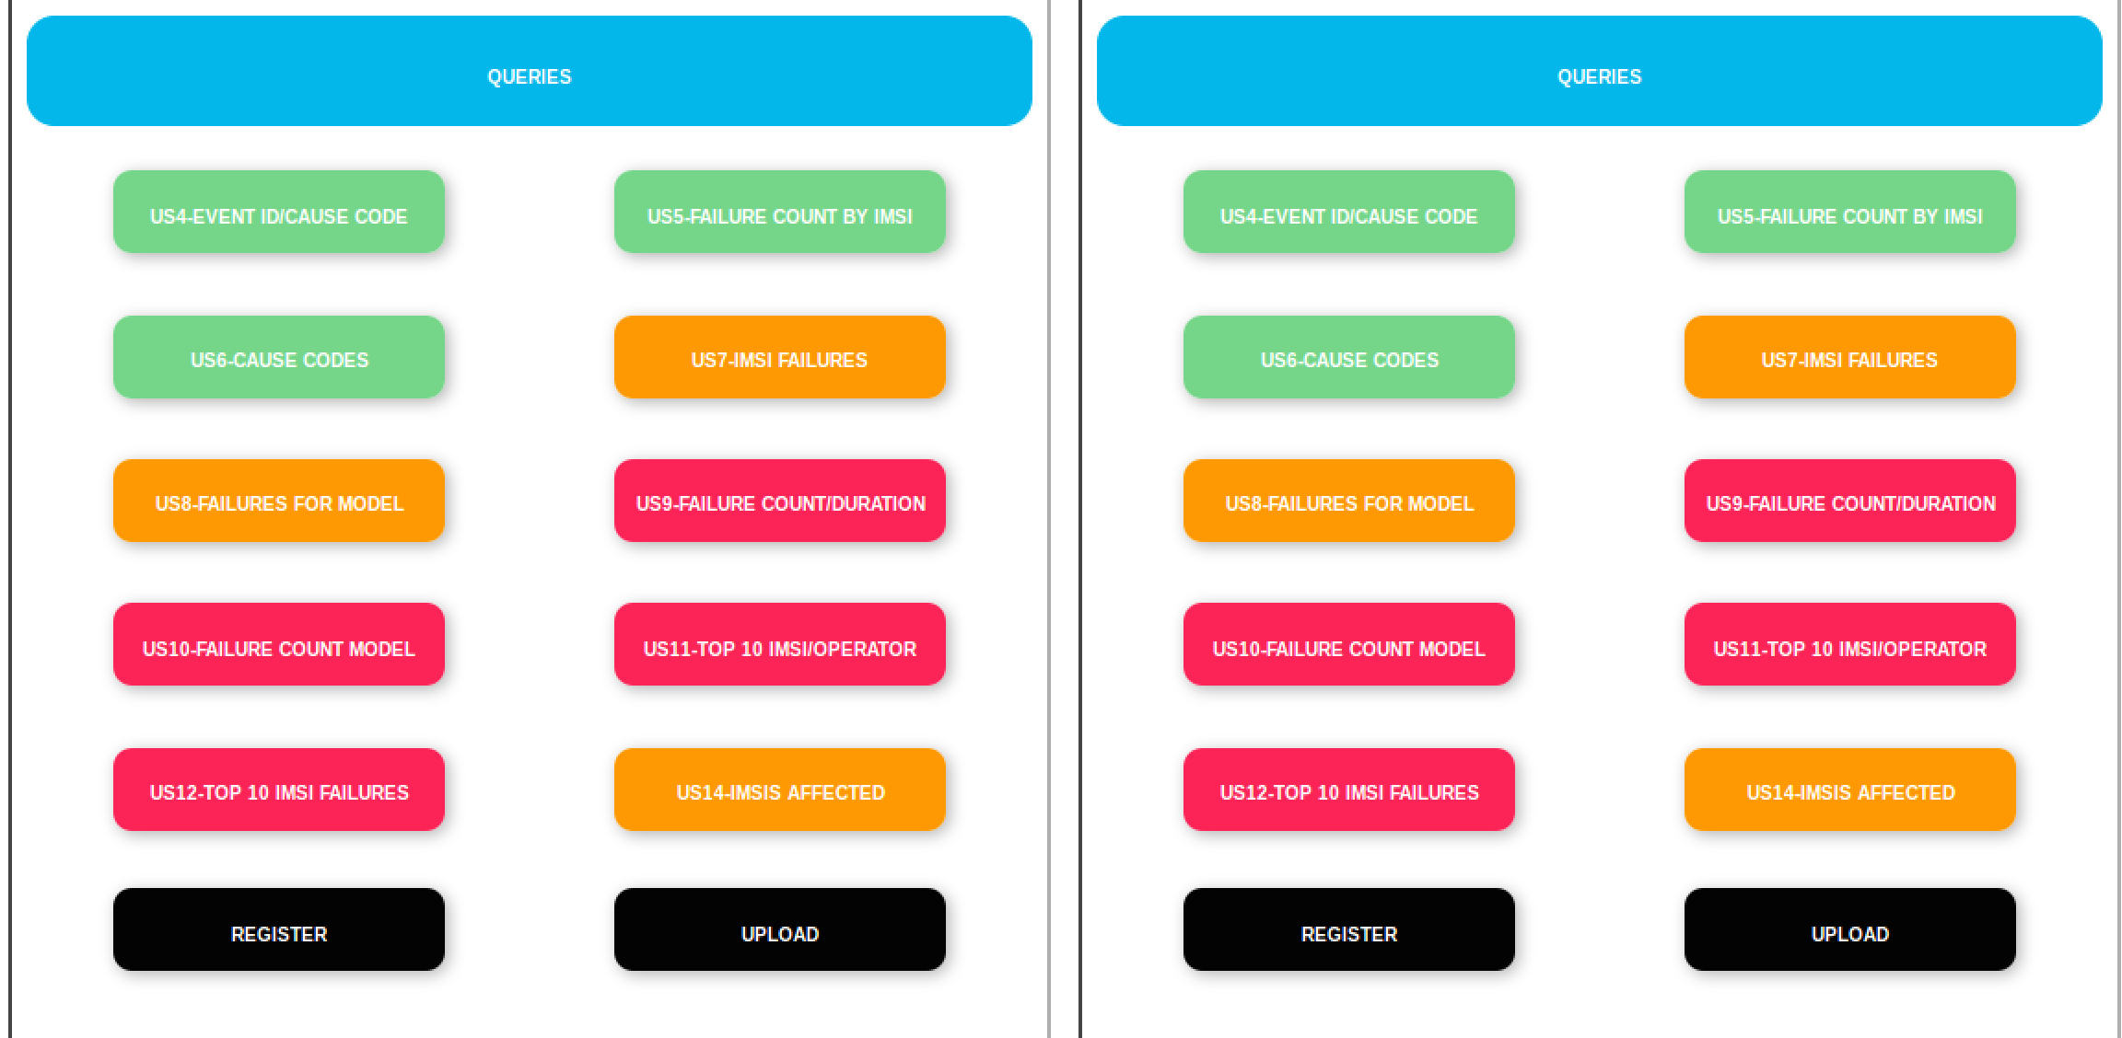

The combo query page displays two identical query pages side by side. Two queries can be selected, performed and their results viewed at any one time.

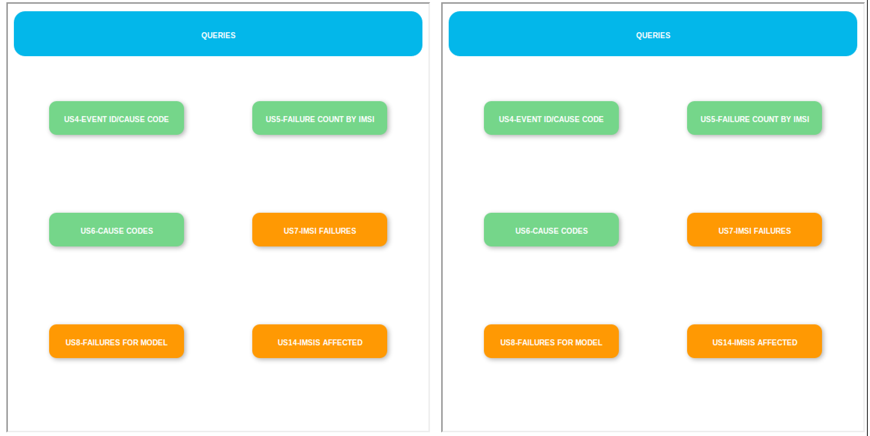

Different levels of access show only queries they can access, their own and those of levels below them.

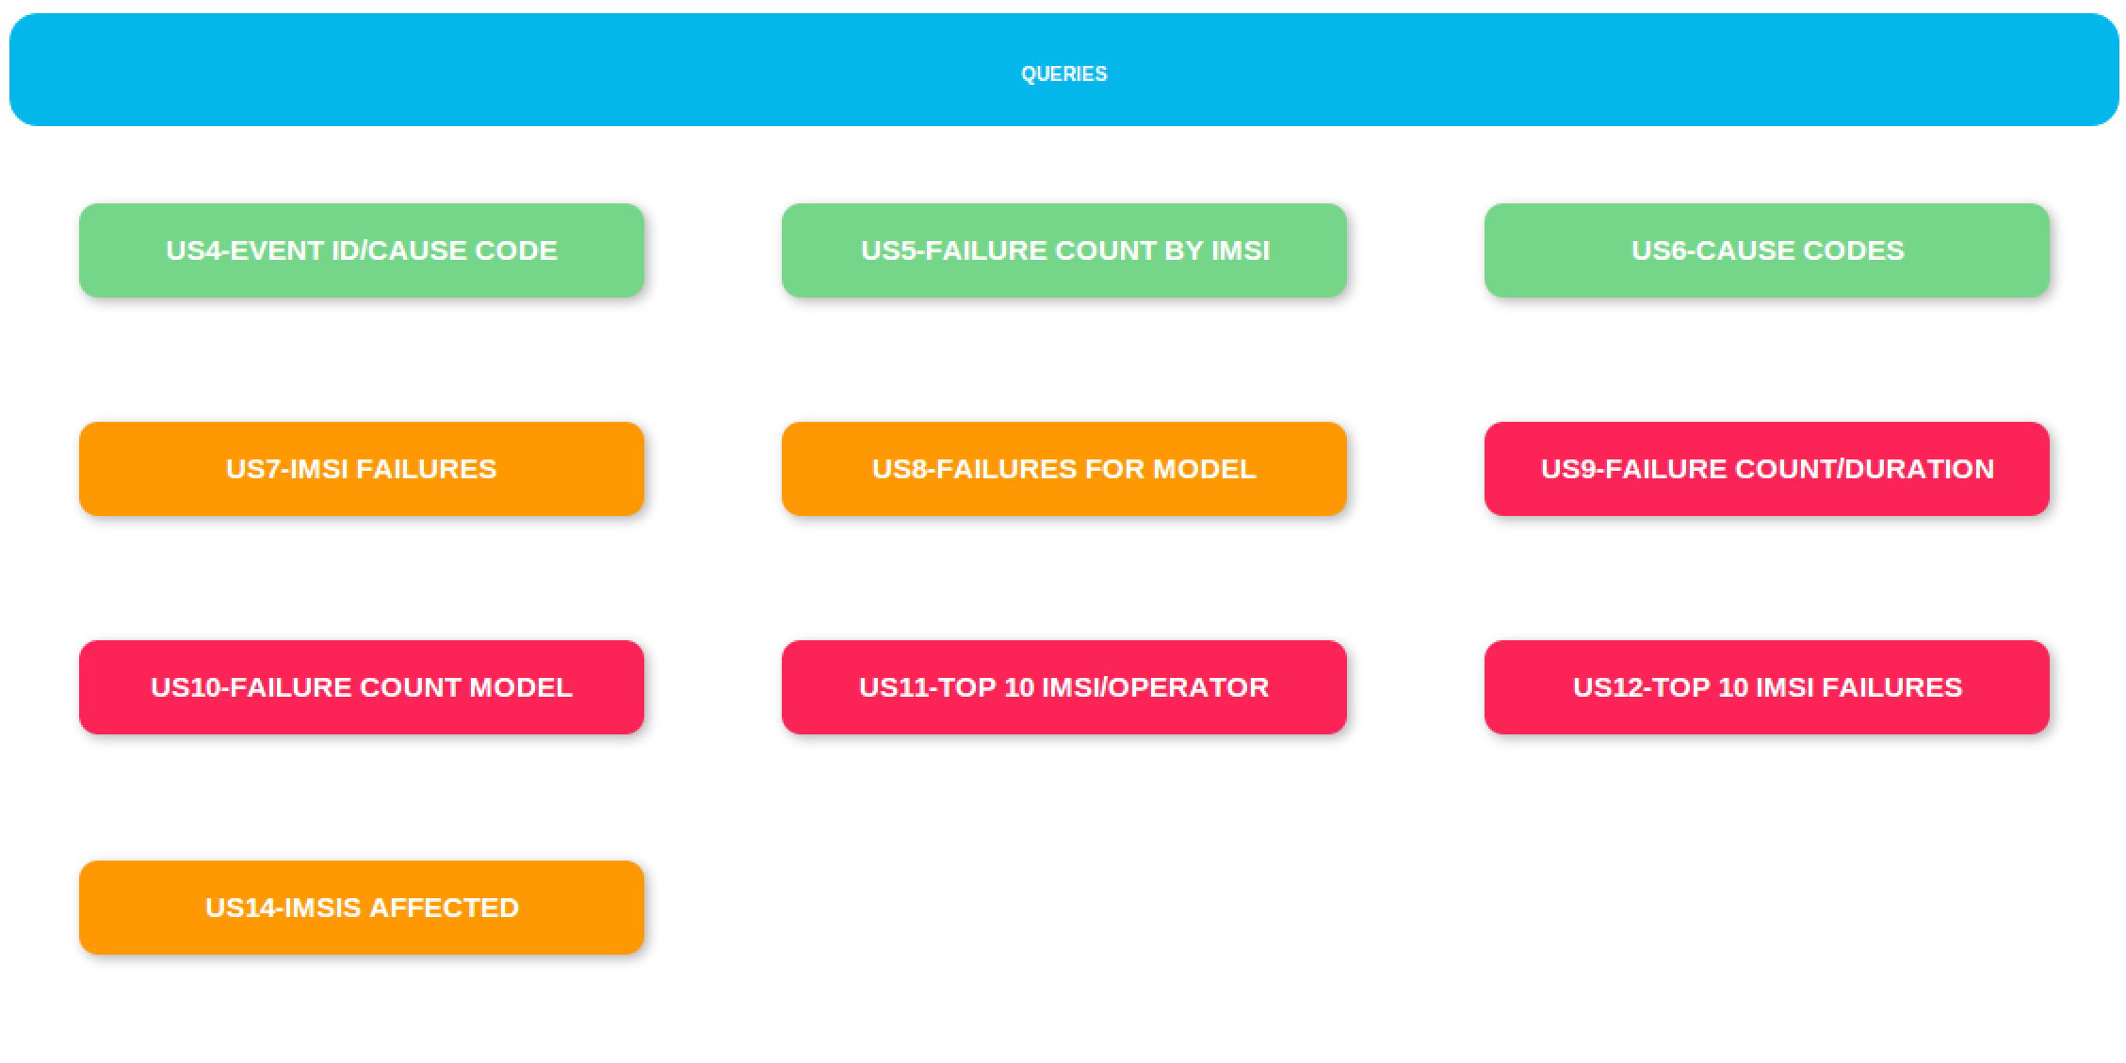

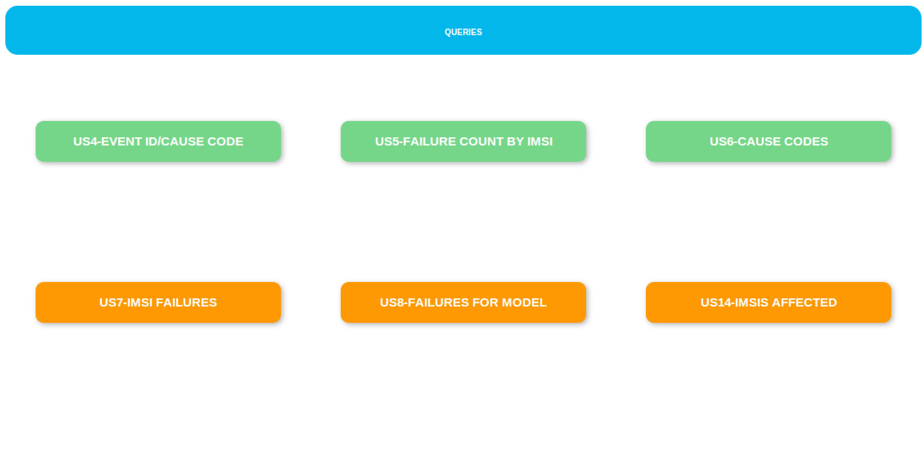

The same is true for the main query page.

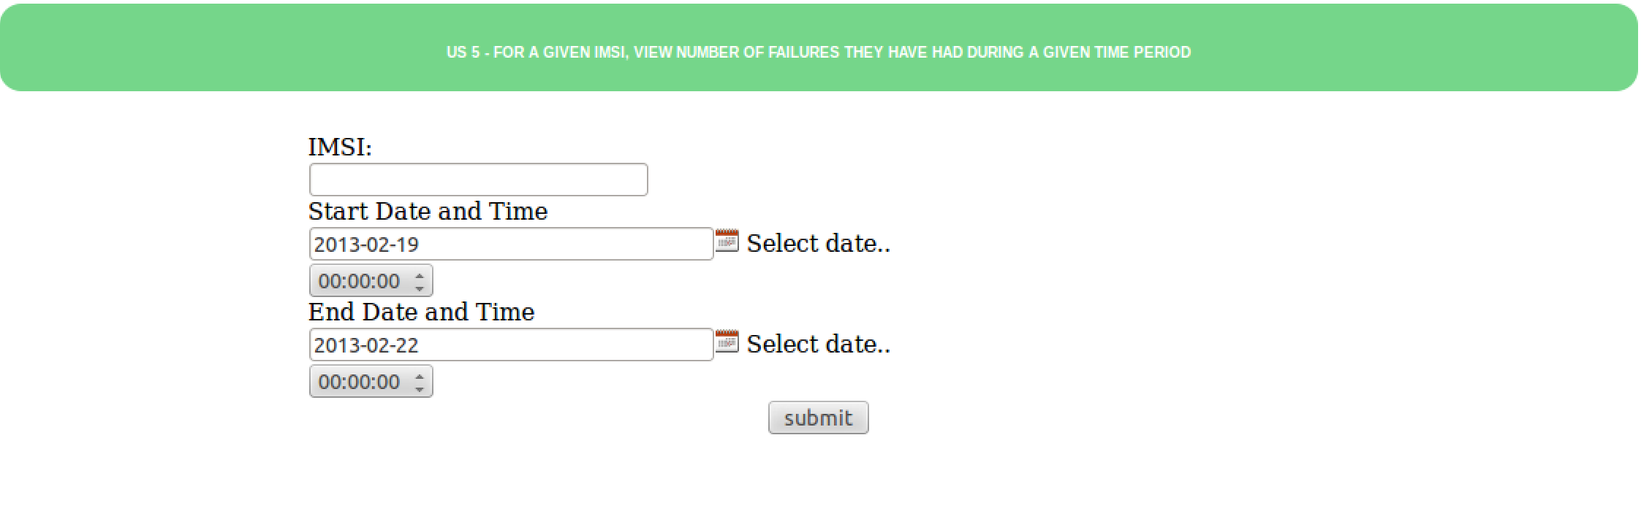

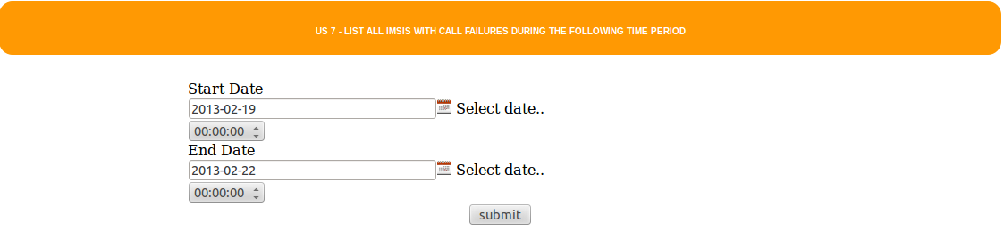



Clicking a query button displays the respective query page to the user, again colour coded, for the user to input data and view the results from the database.

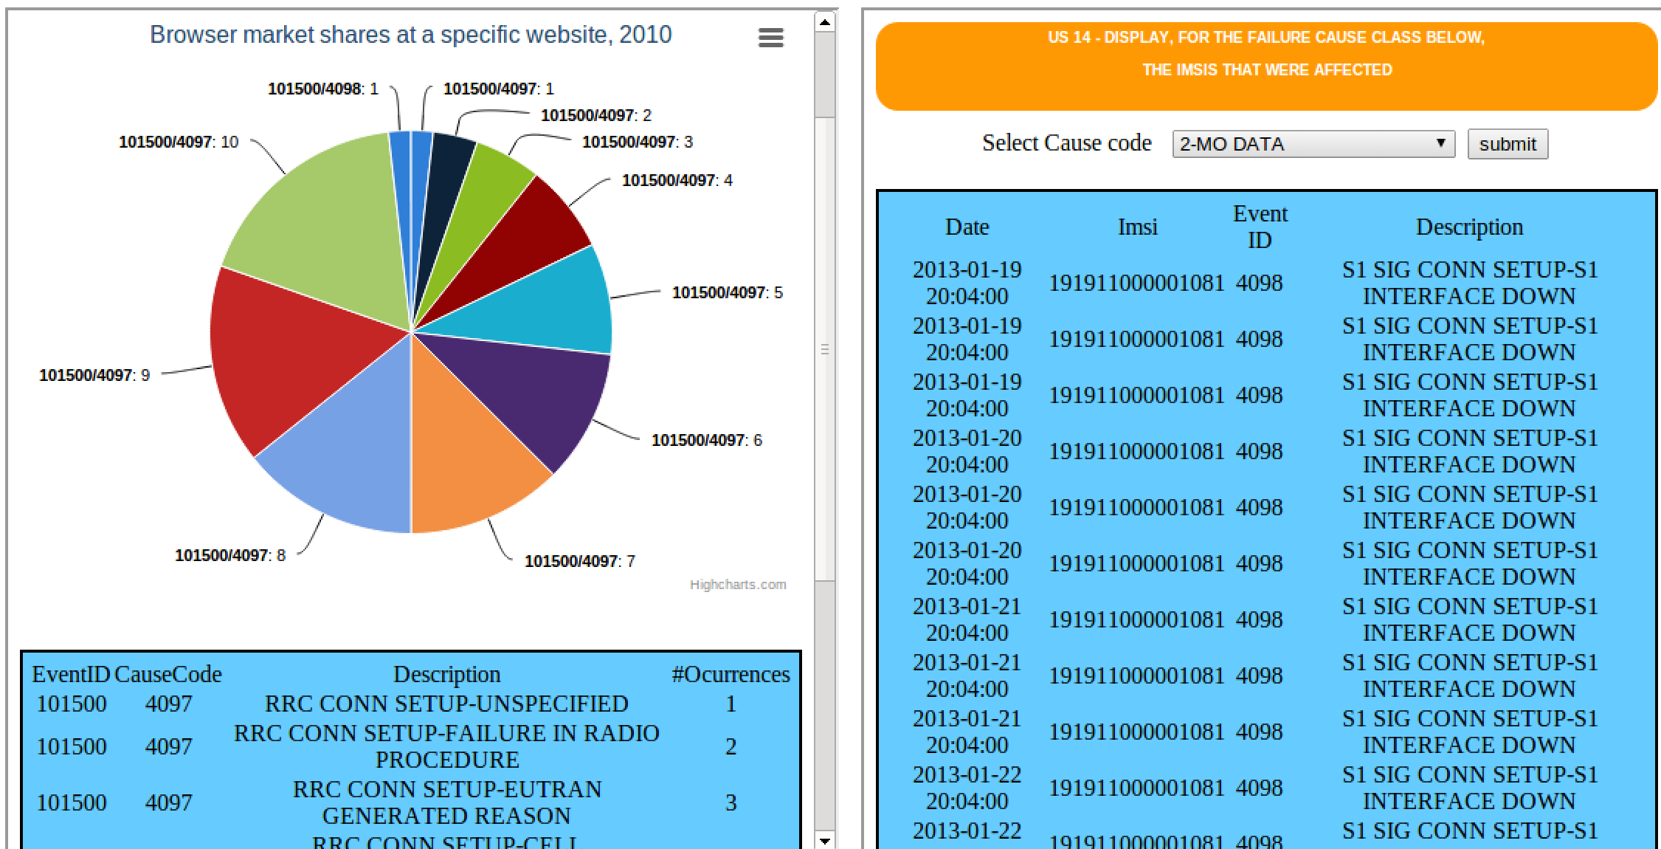

The results are then displayed on the same frame, either main or mini, for the users review.

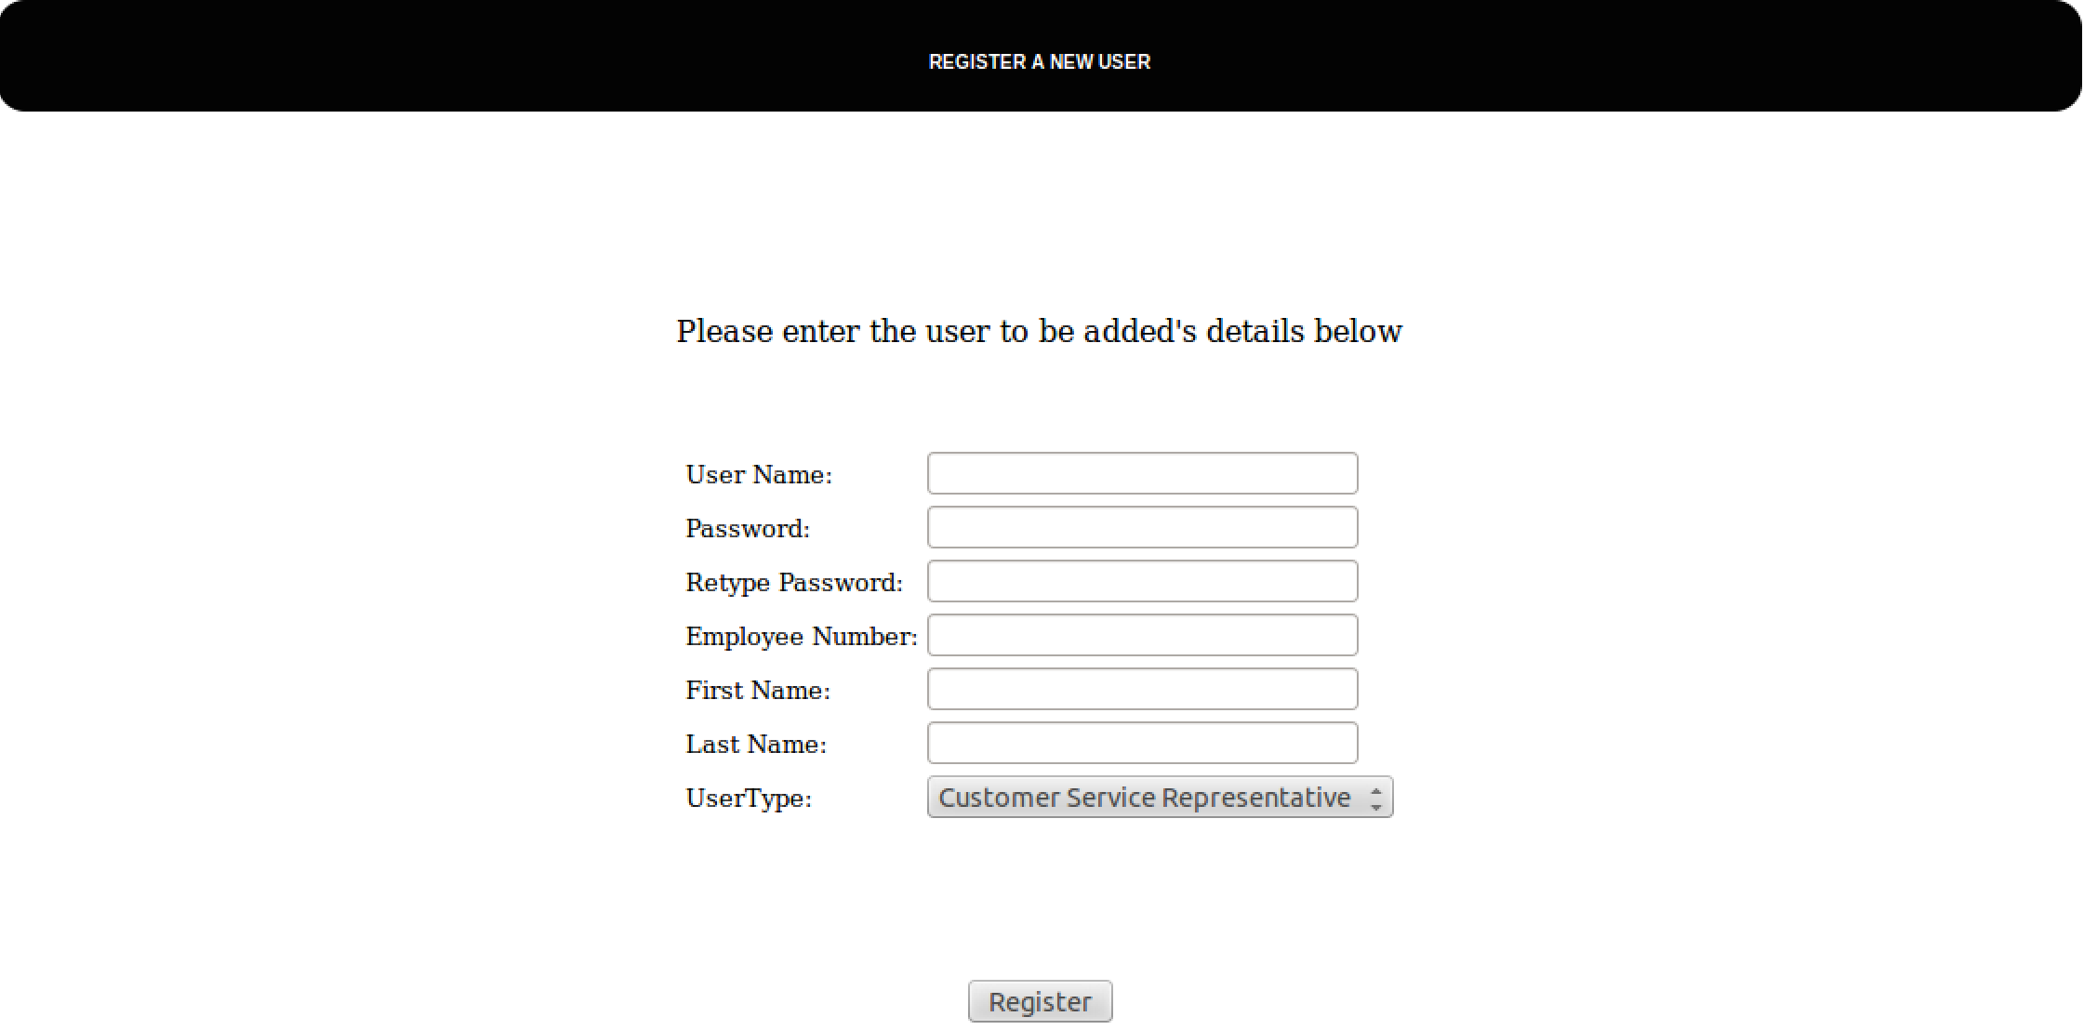



The System Administrator can add new users and populate the database.



Any unauthorised attempted access of a page, either through the address bar or another exploit, directs the user to this redirect page. Clicking it sends the user back to the login page.

On clicking the logout button on the main page, the user is then sent to the login page and the users access level is reset.